Core Ecological Metrics for each Priority Resilience Activity
Marsh Restoration (see Appendix A)
- Plant species metrics (e.g. percent cover by plant species)
- Water level (to calculate inundation)
- Elevation
- Shoreline position

Living Shoreline Restoration (see Appendix A)
- Plant species metrics (e.g. percent cover by plant species)
- Water level (to calculate inundation)
- Elevation
- Shoreline position
- Acres of oyster reef restored (if applicable)

Beach and/or Dune Restoration (see Appendix B)
- Shoreline position
- Beach width
- Elevation
- Volume
- Shoreface
- Backshore width
- Dune width
- Dune height
- Dune volume
- Grain size
Floodplain restoration (see Appendix C)
- Plant species metrics (e.g. percent cover by plant species)
- Elevation
- Water level

Emergency Coastal Resilience Fund: Project Monitoring Plan Template

Use the following tables to provide more detailed information on the monitoring requested by NFWF for the type of restoration work for which you have been funded, even if the monitoring will be funded by other sources than your NFWF grant. You MUST use the associated appendix table to help you fill out the tables for your project.

Goal of project: [In one sentence, please describe the primary goal of the project].

Monitoring approaches for Marsh Restoration and/or Living Shorelines
[You must use Appendix A to complete this table]
Marsh Restoration and/or Living Shorelines
Metric (include units) | Difference to Recommended Methods and Protocols (if any) | Spatial extent of metric monitoring | Baseline yr | Frequency/ Timing | Data Limitations/ Considerations
Percent Cover of biomass by species or cover type (% ranging from 0-100)
Elevation (cm)
Shoreline Position
Water level
Oyster reef restored (acres)[if applicable]

Monitoring approaches for Beach/Dune Restoration
[You must use Appendix B to complete this table]
Beach and Dune Restoration
Metric (include units) | Difference from Recommended Methods and Protocols (if any) | Spatial extent of metric monitoring | Baseline yr | Frequency/ Timing | Data Limitations/ Considerations
Shoreline position (cm)
Beach width (cm)
Elevation (cm)
Volume (cm³)
Shoreface (cm)
Backshore width (cm)
Dune width (cm)
Dune height (cm)
Dune volume (cm³)
Grain size (mm)

Monitoring approaches for Floodplain restoration
[You must use Appendix C to complete this table]
Floodplain Restoration
Metric (include units) | Difference to Recommended Methods and Protocols (if any) | Spatial extent of metric monitoring | Baseline yr | Frequency/ Timing | Data Limitations/ Considerations
Percent Cover of biomass by species or cover type (% ranging from 0-100)
Elevation (cm)
Water level

Appendix A: Metrics and Methods for Monitoring Marsh/Living Shoreline Restoration

Monitoring Overview: Use permanent transects perpendicular from the shore line with quadrat plots to sample changes in plant community, water encroachment and changes in elevation over time.

General guidelines for using transects and quadrats method:
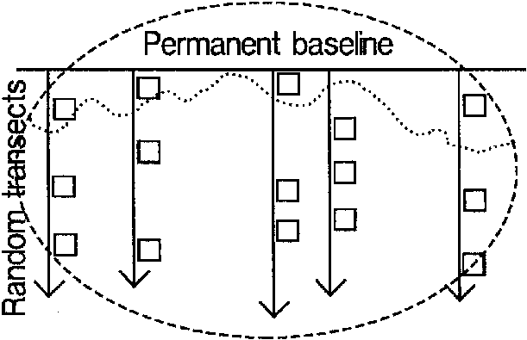
- These guidelines are relevant for the following metrics: Percent cover of biomass, Elevation, and Shoreline position.
- Initial placement of transects must be random and stratified, and then quadrats are placed along those transects. Be sure to capture the edge.
- Transects should capture the seaward edge of marsh vegetation, capture transition zones in elevation or vegetation, and continue through the upper marsh or approximate MHHW, different elevations, upper elevation, and different regions within the site.
Figure 1: Sketch of random transects and quadrats
- Use 1 m² plots.
- Use ~25-50 plots, depending on the size of the project.
- Permanent plots are preferred, as they facilitate capturing change over time, and once established they reduce sampling time. However, but be careful when walking across the same areas over time as this can result in visible damage to the restoration. Be sure to avoid walking within the plot area itself.
- If there are unique vegetation zones (i.e. low marsh, high marsh, etc.) it may be valuable to use a stratified random design (where the strata are the vegetation/elevation zones) with randomization occurring within each strata. For example, if there are two zones of relatively equal size and 6 quadrats total, three would be placed at randomly determined locations (along the transect) within each zone. If zones are substantially different in width, it may be worth distributing the sample plots proportionally.
Guidelines for estimating Percent Cover of Biomass:
- Identify all plant species found in the quadrat. For each species, estimate and record the total percent cover by category (1-9 according to the NCVS vegetation categories outlined below; Peet et al. 1998). Using the same coverage categories, identify and record the cover of live oyster, live mussels, and wrack.
Cover Range | NCVS category
Solitary/Few/Small | 1
0.1-1% | 2
1-2% | 3
2-5% | 4
5-10% | 5
10-25% | 6
25-50% | 7
50-75% | 8
75-95% | 9

- Materials needed: meter sticks, PVD quadrat, clipboards and datasheets
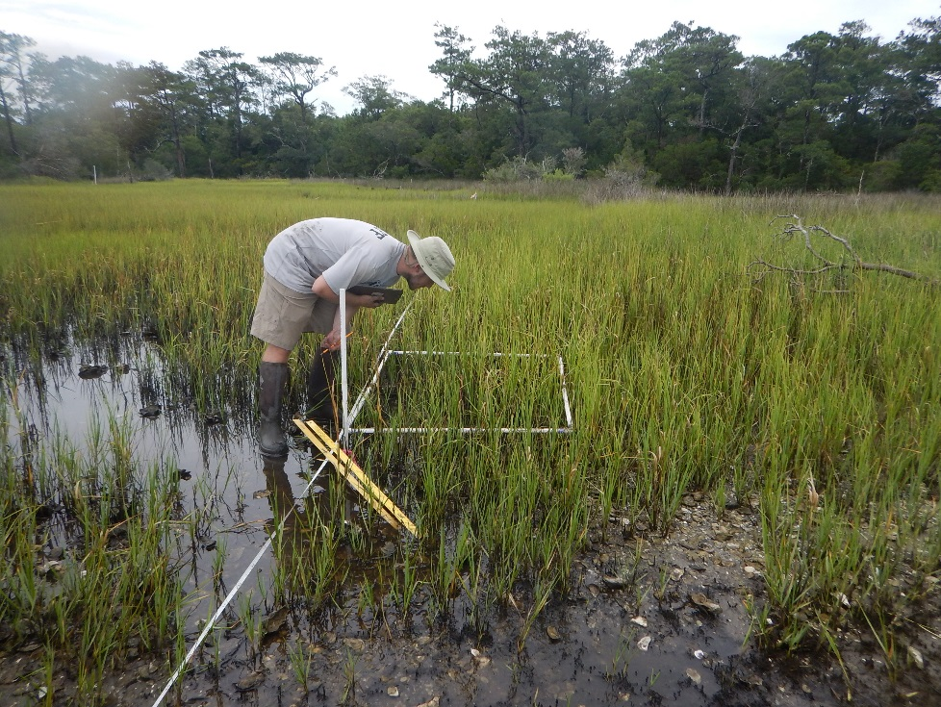
Figure 2: Estimating percent cover at permanent sampling location along transect. Take care to walk on opposite side of transect tape to avoid inadvertently standing in plot when setting up transect tape.
General guidelines for Benchmarking:
- These guidelines are relevant for the following metrics: Elevation and Water Level
- Establish a benchmark into a fixed location using materials that can withstand the saltwater environment. A steel rod driven >5’ into the ground and encased in concrete is acceptable (see TGBM in figure 2 below). Establish ~1 benchmark for every acre of project.
- Follow the protocol laid out in SOP:3 (Lynch, J. C., P. Hensel, and D. R. Cahoon. 2015). The surface elevation table and marker horizon technique: A protocol for monitoring wetland elevation dynamics.
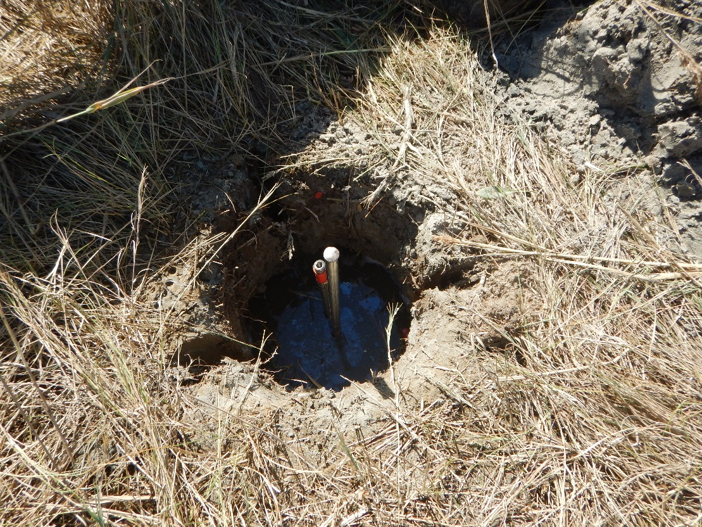
Figure 3: Rod installed into ground before installation of cement-filled PVC collar.
Figure 4: Rod with PVC “collar” filled with cement

Guidelines for Elevation monitoring:
- Laser or optical leveling techniques to determine difference in elevation (~cm of change) from a benchmark to each permanent plot.
- These techniques provide consistent results, and the ability to measure change over time, when reliant on a permanent reference benchmark. If none are available, one should be installed.
- Marsh surface elevation can also be obtained with RTK GPS units, which will also provide best results with a permanent benchmark.
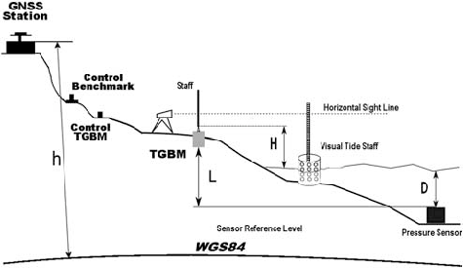
- Place the leveling rod/rover pole in the center of the plot. If the ground is very soft, you may need to use a small item placed on the sediment surface to keep the leveling rod from sinking in the mud while you take your reading (the lid of a Tupperware container works well). If you do this, be sure to use it on all plots throughout the site.
Figure 5: Sketch depicting monitoring site including various equipment and location of measurements within the site.

Guidelines for Water Level monitoring:
- A pressure sensor-style water level logger (Onset or similar, www.onsetcomp.com) should be installed on site. Be sure to select a model that is resistant to saltwater.
- The sensor should be attached to a stable fixed structure (piling or pier) if one is available. If not, attach the sensor to a PVC or rebar pole driven into the substrate far enough to ensure stability (several feet depending on how consolidated the substrate is).
- Sensors can be installed inside of a vented PVC pipe for added protection. The sensor should be attached firmly so that there is no movement in position of the reading lens over time.
- Ideally, to capture the full range of the tide, the sensor should be installed below MLW if at all possible.
- An additional barometric sensor should be installed nearby so that water levels may be corrected for changes in atmospheric pressure (per manufacturer instructions).
- Determine the elevation of the installed sensor relative to the benchmark so that water levels may be interpreted with respect to marsh surface elevation.
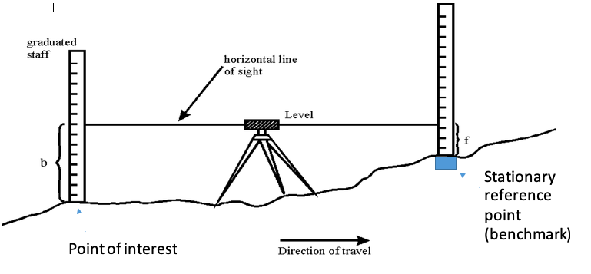
Figure 6: Sketch of leveling technique

Metrics and Protocols:
Metric Name (include units) | Recommended data collection protocols | Spatial extent of metric monitoring | Frequency/ Timing | Use of metric
Percent Cover of biomass by species or cover type (% ranging from 0-100) | Use transects and quadrants method. In each quadrant determine the % of canopy cover (e.g. aerial view looking down) for each plant species. | At each quadrant | Annually around the time of peak marsh biomass (e.g. July-August). Pre- and post- construction. | Increased biomass can result in higher functioning of the marshland for resilience purposes.
Elevation (cm) | Use benchmark method with a laser level, optical level, or an RTK GPS unit. | At each quadrant | Annually in the same seasons every year (e.g. spring and fall every year) and after storm events. Pre- and post- construction. | Provides range of elevation over which marsh species occur (useful for diagnosing plant failure or species shifts). Provides change in elevation (~ 1 cm resolution when tied to a permanent benchmark).
Shoreline position | When establishing your quadrants for the plant community monitoring, include permanent quadrant at the shoreline (e.g. at the edge of vegetation). Mark the edge landward and seaward. | Shoreline quadrant | Annually in the same seasons every year (e.g. spring and fall every year). Pre- and post- construction. | This measurement will give you an idea about the impacts to the shoreline (i.e. wave energy, erosion, design success, etc.)
Water Level (the measure of time and/or water depths that tidal water is over the marsh surface) | Measure water level and marsh surface elevation to the same established benchmark reference point. Water level can be measured with loggers. Most projects will likely only require 1 logger, though large projects may need more. | Loggers should be installed in adjacent subtidal or low intertidal areas. | Measure at 5 to 15 minute intervals for at least 30 days, preferably a year. Pre-construction preferred. | This measurement is needed to calculate the amount of time that the water level is greater than the marsh surface level, e.g. inundation. The distribution of marsh plant species is determined by inundation and salinity. Although it is not a measure of restoration success, measures of inundation time that marsh is covered by tidal water provides valuable data on where the marsh is in the tidal frame. Ideally, this should be determined BEFORE the restoration.
Oyster reef restored (acres) | Only if applicable. Mark edge of restored oyster bed. | Entire reef | Bi-annually in the same seasons every year (e.g. spring and fall every year). Pre- and post- construction. | Document the change in restored oyster reef over time.

Additional Resources:
For more information on the installation of a steel rod with a receiver for attachment of a SET arm visit: https://irma.nps.gov/DataStore/Reference/Profile/2225005

For more information on installing a SET and standard operating procedures see: https://www.nfwf.org/coastalresilience/Documents/nos-set-protocol-installation-sop3.pdf

For more information on the North Carolina Vegetation Survey (NCVS) protocols for recording vegetation percent cover see: https://www.nfwf.org/coastalresilience/Documents/ncvs-protocol.pdf

Appendix B: Metrics and Methods for Monitoring Beach and Dune Restoration
Monitoring Overview: Use permanent transects perpendicular from the shore line with quadrat plots to sample changes in plant community, water encroachment and changes in elevation over time. Use a sand gauge or core samples to monitoring sand grain size.

General guidelines for using cross-shore topographic profile method:
- These guidelines are relevant for the following metrics: Shoreline position, Beach width, Elevation, Volume, Shoreface, Backshore width, Dune width, Dune height, and Dune volume
- Beach profile monitoring uses survey transects running shore normal from the landward dune toe to the low water mark (MLW) or closure depth depending on project goals, beach type and location. The beach profile provides information used to assess whether a shoreline is eroding or accreting, changes to key features, along with elevation and sand volume changes at the selected site.
- Establish transects every 400-800 ft. for long-term monitoring for resilience projects. Shorter transect intervals provide greater data density that may be beneficial for analysis objectives depending on project goals. Establish the baseline relatively parallel to the shoreline and then create individual measuring stations for transects perpendicular to the shoreline. Be sure to establish transects at changes in topography. Survey an initial baseline pre-construction which will indicate where to start monitoring post-construction. Transects should be established in control areas beyond the project site. Control profiles should go beyond the project area, ~1,000 feet beyond any major structures or up to 1/2 mile for fairly long beaches without major features.
- Measure at a minimum to mean-high waterline using an RTK GPS or a total station electronic transit. Start survey on landward side of project, and move seaward taking regular interval data points include at all changes in slope, key features (dune toe, swales, berms, berm ponds, ridges, runnels, wrack and high water lines, etc.) and any significant changes in elevation as you cross over the transect site. The Maximum distance between points on the beach can be 20 ft., to verify no significant change in elevation. Surveys should move into the water’s edge at low tide to maximize the extent of coverage area. Take sufficient measurements of elevation and distance along the profile that includes all changes in slope to accurately establish the profile cross section. The spacing between profiles and the frequency of surveying depends amongst other things on the type of beach, the reason for collecting the data and financial constraints.
- When surveying the profile, reference measurements to a survey benchmark with a known survey datum. Modern GPS systems using RTK station networks allow for virtual benchmark establishment.
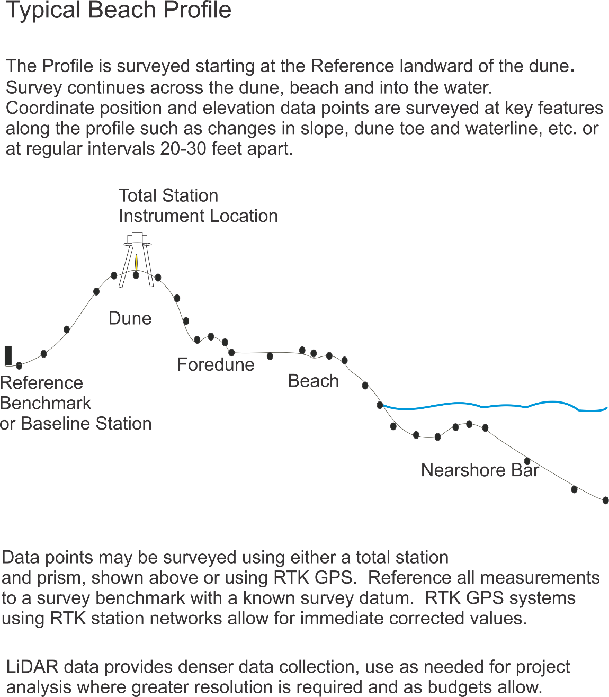
Figure 7: Sketch of Beach Profile Method
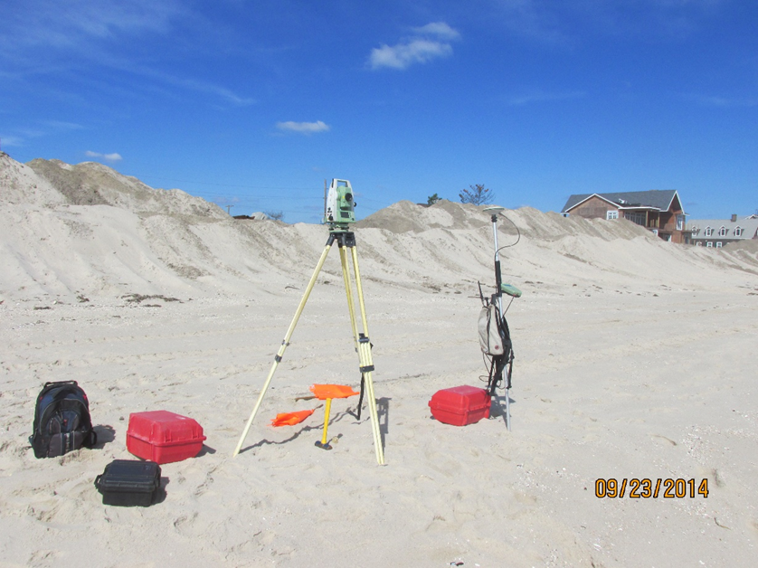
Figure 8: Image of traditional survey equipment used for Beach Profiles (Total Station and RTK GPS Rover)
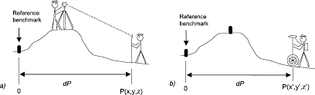
Figure 9: Character sketch of beach profiling using a) Total Station and b) RTK GPS

General guidelines for core samples:
- These guidelines relevant for the following metric: Grain size
- Recommend 20cm thick Core Samples. Taken from dune base to lower beachface slope to determine textural variability across the beach system. Processing method typically used sieving considered adequate, simple method for size determination of sand ranges.
General Guidelines for Sand Gauge:
- These guidelines relevant for the following metric: Grain size
- This is more low-tech than core samples. This method of measuring sand size can be conducted in the field. These are small, credit-card sized, plastic charts with calibrated samples of sieved sand mounted on the face. Allows use of a hand-lens and sand gauge chart, to compare beach samples with calibrated samples for an estimate of the grain size
Metrics and Protocols:
Metric Name (include units) | Recommended data collection protocols | Spatial extent of metric monitoring | Frequency/ Timing | Use of metric
Shoreline position (cm) | Cross-shore topographic profile. RTK GPS following shoreline and beach berm | Statistically significant changes in shoreline position measurements along profile taken no greater than 20 feet onshore 30-40 feet offshore | Bi-annually in the same seasons every year (e.g. spring and fall every year) and after storm events. Pre- and post- construction. | This measurement (in combination with others) will give you an idea about the impacts to the shoreline (i.e. wave energy, erosion, design success, etc.)
Beach width (cm) | Cross-shore topographic profile | See general guidelines above | Bi-annually in the same seasons every year (e.g. spring and fall every year) and after storm events. Pre- and post- construction. | This measurement (in combination with others) will give you an idea about the impacts to the shoreline (i.e. wave energy, erosion, design success, etc.)
Elevation (cm) | Cross-shore topographic profile | Statistically significant changes in elevation measurements along profile taken no greater than 20 feet onshore 30-40 feet offshore | Bi-annually in the same seasons every year (e.g. spring and fall every year) and after storm events. Pre- and post- construction. | This measurement (in combination with others) will give you an idea about the impacts to the shoreline (i.e. wave energy, erosion, design success, etc.)
Volume (cm³) | Cross-shore topographic profile | See general guidelines above | Bi-annually in the same seasons every year (e.g. spring and fall every year) and after storm events. Pre- and post- construction. | Tells how the beach develops and performs in storms
Shoreface (cm) | Cross-shore topographic profile | See general guidelines above | Bi-annually in the same seasons every year (e.g. spring and fall every year) and after storm events. Pre- and post- construction. | Tells how the beach develops and performs in storms.
Backshore width (cm) | Cross-shore topographic profile | See general guidelines above | Bi-annually in the same seasons every year (e.g. spring and fall every year) and after storm events. Pre- and post- construction. | This measurement (in combination with others) will give you an idea about the impacts to the shoreline (i.e. wave energy, erosion, design success, etc.)
Dune width (cm) | Cross-shore topographic profile | See general guidelines above | Bi-annually in the same seasons every year (e.g. spring and fall every year) and after storm events. Pre- and post- construction. | This measurement (in combination with others) will give you an idea about the impacts to the shoreline (i.e. wave energy, erosion, design success, etc.)
Dune height (cm) | Cross-shore topographic profile | See general guidelines above | Bi-annually in the same seasons every year (e.g. spring and fall every year) and after storm events. Pre- and post- construction. | This measurement (in combination with others) will give you an idea about the impacts to the shoreline (i.e. wave energy, erosion, design success, etc.)
Dune volume (cm³) | Cross-shore topographic profile | See general guidelines above | Bi-annually in the same seasons every year (e.g. spring and fall every year) and after storm events. Pre- and post- construction. | Tells how the beach develops and performs in storms. Also relevant for FEMA interests.
Grain size (mm) | Core sample or Sand gauge chat | See general guidelines above | Bi-annually in the same seasons every year (e.g. spring and fall every year) and after storm events. Pre- and post- construction. | Can be an indication of change in slope and accretion. Helps to determine what kind of wave energy is needed to move sand around.

Additional resources:
For more information on conducting a Cross-Profile Topographic Profile visit:
- https://www.escp.org.uk/topographic-beach-survey
- https://www.niwa.co.nz/coasts-and-oceans/nz-coast/learn-about-coastal-environments/beach-types/beach-profile-monitoring-sites
- https://fcit.usf.edu/florida/teacher/science/mod2/resources/beach.profiles.pdf

Appendix C: Metrics and Methods for Monitoring Floodplain Restoration

Monitoring Overview: Use permanent transects perpendicular from the shore line with quadrat plots to sample changes in elevation and water level over time.

General guidelines for using transects and quadrats method:
- These guidelines are relevant for the following metric: Percent Cover of Biomass, Elevation
- Initial placement of transects must be random and stratified, and then quadrats are placed along those transects. Be sure to capture the edge.
- Transects should capture the seaward edge of marsh vegetation, capture transition zones in elevation or vegetation, and continue through the upper marsh or approximate MHHW, different elevations, upper elevation, and different regions within the site.
Figure 40: Sketch of random transects and quadrats
- Use 1 m² plots.
- Use ~25-50 plots, depending on the size of the project.
- Permanent plots are preferred, as they facilitate capturing change over time, and once established they reduce sampling time. However, but be careful when walking across the same areas over time as this can result in visible damage to the restoration. Be sure to avoid walking within the plot area itself.
- If there are unique vegetation zones (i.e. low marsh, high marsh, etc.) it may be valuable to use a stratified random design (where the strata are the vegetation/elevation zones) with randomization occurring within each strata. For example, if there are two zones of relatively equal size and 6 quadrats total, three would be placed at randomly determined locations (along the transect) within each zone. If zones are substantially different in width, it may be worth distributing the sample plots proportionally.
Guidelines for estimating Percent Cover of Biomass:
- Identify all plant species found in the quadrat. For each species, estimate and record the total percent cover by category (1-9 according to the NCVS vegetation categories outlined below; Peet et al. 1998). Using the same coverage categories, identify and record the cover of live oyster, live mussels, and wrack.
Cover Range | NCVS category
Solitary/Few/Small | 1
0.1-1% | 2
1-2% | 3
2-5% | 4
5-10% | 5
10-25% | 6
25-50% | 7
50-75% | 8
75-95% | 9

- Materials needed: meter sticks, PVD quadrat, clipboards and datasheets
General guidelines for Benchmarking:
- These guidelines are relevant for the following metrics: Elevation and Water Level
- Establish a benchmark into a fixed location using materials that can withstand the saltwater environment. A steel rod driven >5’ into the ground and encased in concrete is acceptable (see TGBM in figure 2 below). Establish ~1 benchmark for every acre of project.
- Follow the protocol laid out in SOP:3 (Lynch, J. C., P. Hensel, and D. R. Cahoon. 2015). The surface elevation table and marker horizon technique: A protocol for monitoring wetland elevation dynamics.
Figure 11: Rod installed into ground before installation of cement-filled PVC collar.
Figure 12: Rod with PVC “collar” filled with cement

Guidelines for Elevation monitoring:
- Laser or optical leveling techniques to determine difference in elevation (~cm of change) from a benchmark to each permanent plot.
- These techniques provide consistent results, and the ability to measure change over time, when reliant on a permanent reference benchmark. If none are available, one should be installed.
- Marsh surface elevation can also be obtained with RTK GPS units, which will also provide best results with a permanent benchmark.
- Place the leveling rod/rover pole in the center of the plot. If the ground is very soft, you may need to use a small item placed on the sediment surface to keep the leveling rod from sinking in the mud while you take your reading (the lid of a Tupperware container works well). If you do this, be sure to use it on all plots throughout the site.
Figure 13: Sketch depicting monitoring site including various equipment and location of measurements within the site.

Guidelines for Water Level monitoring:
- A pressure sensor-style water level logger (Onset or similar, www.onsetcomp.com) should be installed on site. Be sure to select a model that is resistant to saltwater.
- The sensor should be attached to a stable fixed structure (piling or pier) if one is available. If not, attach the sensor to a PVC or rebar pole driven into the substrate far enough to ensure stability (several feet depending on how consolidated the substrate is).
- Sensors can be installed inside of a vented PVC pipe for added protection. The sensor should be attached firmly so that there is no movement in position of the reading lens over time.
- Ideally, to capture the full range of the tide, the sensor should be installed below MLW if at all possible.
- An additional barometric sensor should be installed nearby so that water levels may be corrected for changes in atmospheric pressure (per manufacturer instructions).
- Determine the elevation of the installed sensor relative to the benchmark so that water levels may be interpreted with respect to marsh surface elevation.
Figure 14: Sketch of leveling technique

Metrics and Protocols:
Metric Name (include units) | Recommended data collection protocols | Spatial extent of metric monitoring | Frequency/ Timing | Use of metric
Percent Cover of biomass by species or cover type (% ranging from 0-100) | Use transects and quadrants method. In each quadrant determine the % of canopy cover (e.g. aerial view looking down) for each plant species. [metric relevant if the project involves marsh creation through placement of dredge spoils]  Line Intersect method may be used for forested floodplain. | At each quadrant | Annually around the time of peak marsh biomass (e.g. July-August). Pre- and post- construction. | Increased biomass can result in higher functioning of the marshland for resilience purposes.
Elevation (cm) | Use benchmark method with a laser level, optical level, or an RTK GPS unit. | At each quadrant | Annually in the same seasons every year (e.g. spring and fall every year) and after storm events. Pre- and post- construction. | Provides range of elevation over which marsh species occur (useful for diagnosing plant failure or species shifts). Provides change in elevation (~ 1 cm resolution when tied to a permanent benchmark).
Water Level, Primarily Tidal Influence (the measure of time and/or water depths that tidal water is over the marsh surface) | Measure water level and marsh surface elevation to the same established benchmark reference point. Water level can be measured with loggers. Most projects will likely only require 1 logger, though large projects may need more. | Loggers should be installed in adjacent subtidal or low intertidal areas. | Measure at 5 to 15 minute intervals for at least 30 days, preferably a year. Pre-construction preferred. | This measurement is needed to calculate the amount of time that the water level is greater than the marsh surface level, e.g. inundation. The distribution of marsh plant species is determined by inundation and salinity. Although it is not a measure of restoration success, measures of inundation time that marsh is covered by tidal water provides valuable data on where the marsh is in the tidal frame. Ideally, this should be determined BEFORE the restoration.
Water Level, Primarily River Flow Influence | Measure water level and marsh surface elevation to the same established benchmark reference point. Water level can be measured with loggers. Use established river gauge or a staff gauge, surveyed into the same elevation benchmark. Compare on-site results (from data loggers) with river flows (from a river gauge) in order to assess hydrologic connectivity for river influence sites | Nearby established water level gauge | During the rainy season and should capture peak flows during the greatest extent of inundation, and may cover up to 8 months. | This is needed to understand inundation patterns in primarily river flow influenced systems.

Additional Resources:
For more information on the installation of a steel rod with a receiver for attachment of a SET arm visit: https://irma.nps.gov/DataStore/Reference/Profile/2225005

For more information on installing a SET and standard operating procedures see: https://www.nfwf.org/coastalresilience/Documents/nos-set-protocol-installation-sop3.pdf

See attached
https://irma.nps.gov/DataStore/Reference/Profile/2225005. This protocol describes the installation of a steel rod with a receiver for attachment of a SET arm. You will not need the receiver - follow the method for installing stainless rod and encasing it with cement – leaving the top of the rod several inches above the ground surface. This rod will provide the stationery reference point (benchmark) from which to reference marsh surface and water level elevations.
Grantees are welcome to use a method of monitoring any metric which exceeds the accuracy of the recommended monitoring method.
Grantees are welcome to use a method of monitoring any metric which exceeds the accuracy of the recommended monitoring method.
See attached
https://irma.nps.gov/DataStore/Reference/Profile/2225005. This protocol describes the installation of a steel rod with a receiver for attachment of a SET arm. You will not need the receiver - follow the method for installing stainless rod and encasing it with cement – leaving the top of the rod several inches above the ground surface. This rod will provide the stationery reference point (benchmark) from which to reference marsh surface and water level elevations.
Grantees are welcome to use a method of monitoring any metric which exceeds the accuracy of the recommended monitoring method.

