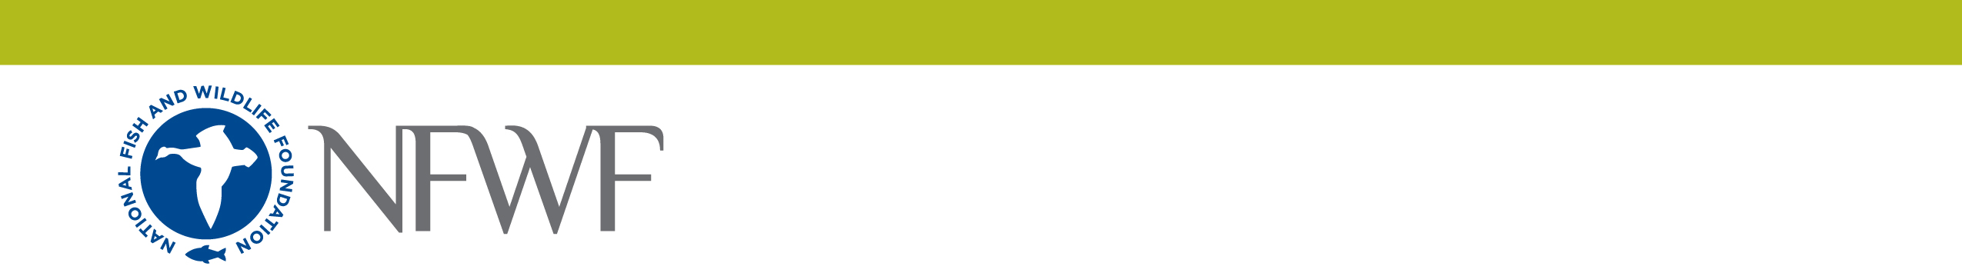
INNOVATIVE NUTRIENT AND SEDIMENT REDUCTION
Full Proposal Project Narrative
Instructions: Save this document on your computer and complete the narrative in the format provided. The final narrative may not exceed ten (10) pages, excluding tables and figures. Please retain the outline format below but you may delete the instructions associated with each element. Once complete, upload this document into the on-line application as instructed.
- Objectives: Summarize the project's primary objectives, specifically with regards to the program goals to accelerate implementation of water quality improvement practices and strengthening the partnerships necessary to scale up implementation efforts.
- Current Water Quality Context – Provide an overview of the current status of efforts to advance water quality improvement for the project’s targeted geographic region, source sectors and/or key audiences, and/or priority water quality improvement practices, consistent with the Chesapeake Bay TMDL and associated state and local Watershed Implementation Plans. Describe current progress towards achieving TMDL, WIP, and local pollution reduction goals for affected regions, sectors, and/or audiences, key factors driving current implementation successes, and major challenges or barriers to accelerated implementation progress.
- Current Partnership Context – Describe the proposed partnership’s current role advancing water quality improvement for the project’s affected targeted geographic region, source sectors and/or key audiences, and/or priority water quality improvement practices. Detail the current roles, responsibilities, and/or functions of the partners, specifically with regards to advancing implementation among targeted regions, sectors, and for priority practices. Identify key strengths or assets of the current partnership’s efforts, as well as the principal gaps, weakness, or deficits currently limiting partners’ collective capacity to scale up implementation.
- Communities Engaged and Impacted: Describe the communities where the project will take place, who will specifically benefit from the project, and how they were or will be engaged in project development and implementation. Provide demographic information on impacted communities, including but not limited to age, race and ethnicity, and socioeconomic indicators.
- Work Plan: Provide a detailed work plan describing: (1) each major task or activity; (2) lead and supporting partners responsible for each task/activity; and (3) a quarterly schedule for completing each activity. In describing major tasks or activities, refer back to key need or opportunities for accelerated implementation you’ve identified in the “Current Water Quality Context” and “Current Partnership Context” sections and specifically address how each task or activity will address major needs or opportunities already identified. Major tasks or activities described here should align tasks and activities described in the Budget Narrative.
- Data Collection Activities: If you propose to collect or analyze data as part of your project it might require additional documentation through a Quality Assurance Project Plan (QAPP). Some examples of data collection or uses that require a QAPP include: new data collection; secondary data use; data collection associated with development or design of plans; monitoring or surveys (for both people and environmental media), mapping environmental processes or conditions (GIS); model development or use, etc. To evaluate whether quality assurance documentation might be needed please provide a short description (one paragraph about the project methods and outputs) of your data collection or analysis activities.
- Tracking and Sustaining Implementation Progress: Describe how you will track additional implementation progress resulting from the proposal, including how the project will document and verify associated load reduction outcomes. Discuss unique plans or elements of your partnership that will support long-term performance and maintenance of implemented practices.
- Dissemination and Transferability of Results: Describe specific mechanisms for the active transfer of results and insights generated from of the project to other parts of the Chesapeake Bay watershed, integration into broader policies and programs, and communication to appropriate audiences. Identify the anticipated methods, techniques and/or findings of this project that are likely to be best applied by others, and discuss the relative strength of these applications to different geographic areas, organizations, etc.

