Healthy American Forests Initiative
REQUEST FOR PROPOSALS

NFWF is committed to operating in full compliance with all applicable laws, regulations, and Executive Orders. We continuously monitor legal and regulatory developments to ensure our policies, procedures, and operations align with current federal directives. We encourage all applicants to do the same.

The ability and extent to which NFWF is able to make awards is contingent upon receipt of funds from federal agencies and/or other funding partners. Final funding decisions will be made based on the applications received and the level and timing of funding received by NFWF.

TIMELINE
Dates of activities are subject to change. Please check the program page of the NFWF website for the most current dates and information.
Healthy American Forests Initiative

Full Proposal Webinar October 8th, 2025
Full Proposal Due Date January 13th, 2026, 11:59 PM, EST
Review Period Mid-January 2026 – May 2026
Awards Announced Mid to late May 2026

Overview
The National Fish and Wildlife Foundation (NFWF), through an agreement from the Department of Agriculture’s U.S. Forest Service (USFS) is pleased to announce the Healthy American Forests Initiative (HAFI) Request for Proposals (RFP). This funding opportunity will support watershed restoration and vegetation management projects on National Forest System lands to achieve a healthy forest ecosystem. Thriving forests lead to more robust timber production which plays a vital role in helping local economies, especially in rural areas, generate jobs and revenue. Moreover, recent disasters have shown that effective forest management and wildfire risk reduction efforts can protect lives and safeguard communities across the United States. Applicants should develop proposals that increase forest management activities and reduce wildfire risk to ultimately promote healthy forests, increase timber productivity and protect American prosperity.

GRANT AWARD INFORMATION
NFWF anticipates this will be a singular funding cycle granting 10-15 awards. The award sizes will range from $250,000 to $2 million and the maximum project length is 2 years. Projects may not have an end date beyond May 30th, 2028. Projects are required to provide non-federal match valued at 20% of total project costs (25% of the grant request to NFWF).

Geographic Focus
Projects must occur on National Forest System lands (NFS), which consists of 154 national forests and 20 national grasslands covering 193 million acres in 43 states, the Virgin Islands, and Puerto Rico. Interactive and downloadable maps of all land administered by the USDA forest service are available here. A map viewer showing USFS Watershed Condition Framework data is available here. The Watershed Condition Framework data identifies priority watersheds and rational for their designation through USFS Watershed Restoration Action Plans.

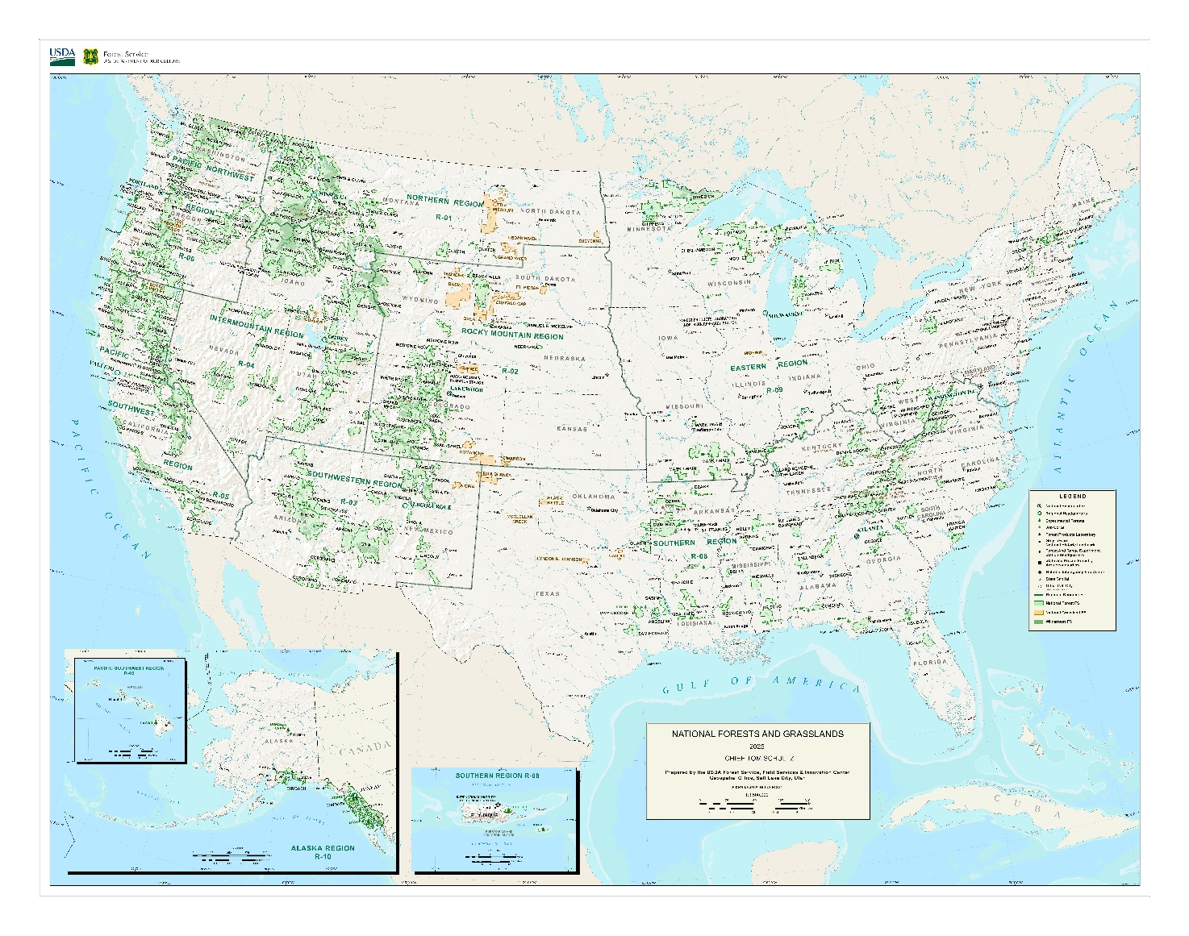
Figure 1: The Chief's Map shows all of the National Forests and Grasslands in the Forest Service. It has the name of the current chief of the Forest Service. The map contains other features such as streams, lakes, and Forest Service facilities and assets.

PROGRAM PRIORITIES
Competitive projects must occur on National Forest System lands and projects must be carried out in accordance with a water source protection plan as developed under section 303(d)(1) of the Healthy Forests Restoration Act (HFRA) of 2003 or a watershed restoration action plan developed under section 304(a)(3) of HFRA of 2003. Applicants should discuss their project with the National Forest Unit in which the project will be implemented prior to submission and obtain a letter of support. National Forest Grants are for vegetation management or watershed restoration projects on National Forest System land. Associated activities may include the removal of vegetation, use of prescribed fire, restoration of aquatic habitat, or decommissioning of an unauthorized, temporary, or system road to enhance or restore the ecological function and health of a forest ecosystem.

Competitive proposals should also address at least one of the following program priorities:
- Expand Habitat Connectivity
- Provide a Range of Ecosystem Services
- Strengthen Ecosystem and Community Health
- Expand Public Access to Nature
- Contribute to local and/or regional economies
- Contribute to Workforce Development

PROJECT METRICS
To better gauge progress on individual grants and to ensure greater consistency of project data provided by multiple grants, the Healthy American Forestry Initiative has a list of metrics in Easygrants for full proposal applicants to choose from for future reporting. We ask that applicants select only the most relevant metrics from this list for their project (all possible program metrics are shown in the table below). If you think an applicable metric has not been provided, please contact Ericka Popovich (Ericka.Popovich@NFWF.ORG) to discuss acceptable alternatives.

Project Activity | Possible Metric | Easygrants Instructions
Habitat Restoration | Fish passage improvements - # passage barriers rectified | Enter the number of aquatic organism passage barriers rectified. In the NOTES section indicate what type(s) of barrier(s) are being removed or replaced (e.g., culvert, dam). Provide the barrier's Southeast Aquatic Resources Partnership ID (see SARP National Aquatic Barrier Inventory: aquaticbarriers.org). If the barrier(s) is not in SARP, provide its latitude and longitude or its name and source.
Habitat Restoration | Fish passage improvements - Miles of stream opened | Enter total # of miles opened to improve aquatic organism passage. Only include the miles of main stem & smaller tributaries connected until the next barrier upstream (or headwaters), but NOT lakes, ponds, or distance downstream from the barrier removed.
Habitat Restoration | Floodplain restoration - Acres restored | Enter # of floodplain acres restored. In the NOTES, indicate % of vegetation on the pre-project site (0-20%, 21-40%, 41-60%, 61-80%, 81-100%) and the dominant vegetation being restored (Broadleaf, Conifer, Redwood, Shrub, Grass, Marsh, Wet meadow, Swamp).
Habitat Restoration | Instream restoration - Miles restored | Enter the number of miles restored
Habitat Restoration | Riparian restoration - Miles restored | Enter total number of riparian forest miles restored.
Habitat Restoration | Removal of invasives - Acres restored | Enter the number of acres restored by removal or control of INVASIVE SPECIES. In the NOTES section, specify: the vegetation type being removed (herbaceous, shrub, or tree), average frequency (in years) the treatment is expected to occur in the future, and whether the removed vegetation will be left on site to decompose (Yes, No). Projects should include post-removal monitoring and follow-up control efforts as necessary to ensure that invasive species do not reinvade.
Habitat Management | BMP implementation for prescribed burns - Acres burned | Enter # acres with prescribed burning. In the NOTES, specify if private or public land, average frequency (in yrs) for future burning, dominant vegetation burned (forest, shrubland, grassland, cropland, Phragmites marsh). If forest, note if trees have been planted in past 10 yrs (Yes, No), and type of forest (Alder-maple, Aspen-birch, Douglas-fir, Douglas-fir with high productivity and high management intensity, Elm-ash-cottonwood, Fir-spruce-mountain hemlock, Hemlock-Sitka spruce, Hemlock-Sitka spruce with high productivity, Loblolly-shortleaf pine, Loblolly-shortleaf pine with high productivity and management intensity, Lodgepole pine, Longleaf-slash pine, Longleaf-slash pine with high productivity and management intensity, Maple-beech-birch, Mixed conifer, Oak-gum-cypress, Oak-hickory, Oak-pine, Ponderosa pine, Redwood, Spruce-balsam fir, Western oak, White-red-jack pine).
Habitat Management | Fuels management treatment (mechanical/hand) - # of acres treated | Enter # acres of vegetation treated by mechanical or hand treatments for wildfire risk reduction. In the NOTES, indicate dominant forest type, average frequency (in years) for future treatments, and whether the removed vegetation will be left on site to decompose (Yes/No).
Capacity, Outreach, Incentives | Building institutional capacity - # of orgs contributing to goals | Enter the number of organizations contributing to the initiative's conservation goals.
Capacity, Outreach, Incentives | Economic benefits - # jobs created | Enter the # of individuals hired to directly work on the project (non-volunteers). Jobs should be directly engaged in grant activities, funded by the grant, and shouldn't have existed prior to the grant. The starting value for this metric should be zero and target value should be a whole number. In the NOTES section, provide the FTE for the jobs created.
Capacity, Outreach, Incentives | Economic benefits - # jobs sustained | Enter the # of paid jobs that are partially or fully sustained through this grant. The starting value for this metric should be zero and target value should be a whole number. Jobs should have existed prior to the grant, be funded by the grant, and be directly engaged in project activities.
Capacity, Outreach, Incentives | Outreach/ Education/ Technical Assistance - # internships/fellowships | Enter the number of people employed as interns, fellows, or youth corps participants.
Capacity, Outreach, Incentives | Outreach/ Education/ Technical Assistance - # people reached | Enter the number of people who responded to an offer of outreach, training, or technical assistance. This number should be a subset of the # of people targeted.
Capacity, Outreach, Incentives | Outreach/ Education/ Technical Assistance - # people targeted | Enter the number of people targeted by outreach, training, or technical assistance activities.
Capacity, Outreach, Incentives | Outreach/ Education/ Technical Assistance - # workshops, webinars, meetings | Enter the number of workshops, webinars, and meetings held to address project activity.
Capacity, Outreach, Incentives | Volunteer participation - # of volunteer hours | Enter the # of volunteer hours in this project, who will be engaged, and what activities they will complete.

ELIGIBILITY
Eligible applicants include non-profit 501(c) organizations, state government agencies, local governments, municipal governments, Tribal Governments and Organizations, and educational institutions.

Ineligible applicants include U.S. Federal government agencies, international organizations, businesses, and unincorporated individuals.

EVALUATION CRITERIA
All proposals will be screened for relevance, accuracy, completeness and compliance with NFWF and funding source policies. Proposals will then be evaluated based on the extent to which they meet the following criteria.

Conservation Outcomes | Technical Merit | Partnership and Community Impact | Budget
- Alignment with program goals and priorities  - Quantifiable performance metrics  - Appropriate monitoring of activities and outcomes  - Project long-term sustainability | - Technically sound and feasible  - Engages technical experts  - Logical and achievable work plan and timeline  - Sound compliance approach (permits, NEPA)  - Accurate spatial data | - Collaborates with local community  - Partners help sustain impact of project  - Proposal identifies communities impacted  - Includes letters of support from community partners | - Allowable and reasonable costs  - Matching contributions  - Cost effective

Conservation Outcomes
- Project occurs on National Forest System lands and projects must is carried out in accordance with a water source protection plan or a watershed restoration action plan.
- Project addresses one or more of the listed Program Priorities and has specific, quantifiable performance metrics to evaluate project success.
- Project includes a plan for monitoring progress during and after the proposed project period to track project success and adaptively address new challenges and opportunities as they arise.
- Project will be maintained to ensure benefits are achieved and sustained over time. This should include how future funding will be secured to implement necessary long-term monitoring and maintenance activities. This ensures long-term sustainability and success of the project.
Technical Merit
- Project engages appropriate technical experts throughout project planning, design and implementation to ensure activities are technically sound and feasible.
- Project sets forth a clear, logical and achievable work plan and timeline.
- Project spatial data submitted to NFWF’s online mapping tool accurately represent the location(s) of conservation activity(ies) at the time of proposal submission. Successful projects will be required to submit improved spatial data for each conservation activity within the period of performance as necessary.

Partnership and Community Impact
- The applicant organization partners and engages collaboratively with local community members, leaders, community-based organizations, and other relevant stakeholders to develop and implement the proposed project to ensure long-term sustainability and success of the project.
- Partners or communities are enlisted to broaden the sustained impact from the project.
- Proposal describes the community characteristics of the project area, identifies any communities impacted, and describes outreach and community engagement activities and how those will be monitored and measured.
- Proposal uses data to support descriptions and submits letters of support from USFS unit(s), community partners, and/or collaborators demonstrating their commitment to the project and engagement in project activities as proposed.
Budget/Cost-Effectiveness
- Costs are allowable, reasonable and budgeted in accordance with NFWF’s Budget Instructions cost categories. Federally funded projects must be in compliance with 2 CRF 200 as applicable.
- Amount requested is proportional to expected outcomes.
- Project includes a cost-effective budget that balances performance risk and efficient use of funds. Cost-effectiveness analysis identifies the most efficient way to meet project objectives. Cost-effectiveness evaluation includes, but is not limited to, an assessment of effective direct/indirect costs across all categories in the proposed budget according to the type, size and duration of project and project objectives. Project budgets will be compared to similar projects to ensure proposed costs across all budget categories are reasonable for the activities being performed and the outcomes proposed.

OTHER
Ineligible Uses of Grant Funds

- NFWF funds and matching contributions are strictly prohibited from being used for a number of reasons to include, for example, political advocacy, fundraising, lobbying, litigation, terrorist activities, or in violation of the Foreign Corrupt Practices Act. See OMB Uniform Guidance for additional information.
- Equipment: Applicants are encouraged to rent equipment where possible and cost-effective or use matching funds to make those purchases. NFWF acknowledges, however, that some projects may only be completed using NFWF funds to procure equipment. If this applies to your project, please contact the program staff listed in this RFP to discuss options.
- Federal funds and matching contributions may not be used to procure or obtain equipment, services, or systems (including entering into or renewing a contract) that uses telecommunications equipment or services produced by Huawei Technologies Company or ZTE Corporation (or any subsidiary or affiliate of such entities) as a substantial or essential component, or as critical technology of any system. Refer to Public Law 115-232, section 889 for additional information.
- NFWF funds may not be used to support ongoing efforts to comply with legal requirements, including permit conditions, mitigation and settlement agreements. However, grant funds may be used to support projects that enhance or improve upon existing baseline compliance efforts.

Environmental Services – NFWF funds projects in pursuit of its mission to sustain, restore and enhance the nation's fish, wildlife, plants and habitats for current and future generations. NFWF recognizes that some benefits from projects may be of value with regards to credits on an environmental services market (such as a carbon credit market). NFWF does not participate in, facilitate, or manage an environmental services market nor does NFWF assert any claim on such credits.

Intellectual Property – Intellectual property created using NFWF awards may be copyrighted or otherwise legally protected by award recipients. NFWF may reserve the right to use, publish, and copy materials created under awards, including posting such material on NFWF’s website and featuring it in publications. NFWF may use project metrics and spatial data from awards to estimate societal benefits that result and to report these results to funding partners. These may include but are not limited to: habitat and species response, species connectivity, water quality, water quantity, risk of detrimental events (e.g., wildfire, floods), and carbon accounting (e.g., sequestration, avoided emissions).

Procurement – If the applicant chooses to specifically identify proposed Contractor(s) for Services, an award by NFWF to the applicant does not constitute NFWF’s express written authorization for the applicant to procure such specific services noncompetitively. When procuring goods and services, NFWF award recipients must follow documented procurement procedures which reflect applicable laws and regulations.

Publicity and Acknowledgement of Support – Award recipients will be required to grant NFWF the right and authority to publicize the project and NFWF’s financial support for the grant in press releases, publications and other public communications. Recipients may also be asked by NFWF to provide high-resolution (minimum 300 dpi) photographs depicting the project.

Receiving Award Funds – Award payments are primarily reimbursable. Projects may request funds for reimbursement at any time after completing a signed agreement with NFWF. A request of an advance of funds must be due to an imminent need of expenditure and must detail how the funds will be used and provide justification and a timeline for expected disbursement of these funds. Requests for monthly advances will not be considered.
Compliance Requirements – Projects selected should expect be subject to requirements under the Endangered Species Act (ESA; state and federal), National Historic Preservation Act (NHPA), and Clean Water Act (CWA), and the National Environmental Policy Act (NEPA). Documentation of compliance with these regulations must be approved prior to initiating any grant funded activities. Applicants may be asked to produce compliance documents and should budget time and resources to obtain the needed approvals. As may be applicable, successful applicants may be required to comply with additional Federal, state or local requirements and obtain all necessary permits and clearances.

Permits – Successful applicants will be required to provide sufficient documentation that the project expects to receive or has received all necessary permits and clearances to comply with any Federal, state, or local requirements. Where projects involve work in the waters of the United States, NFWF strongly encourages applicants to conduct a permit pre-application meeting with the United States Army Corps of Engineers prior to submitting their proposal. In some cases, if a permit pre-application meeting has not been completed, NFWF may require successful applicants to complete such a meeting prior to grant award. The costs associated with compliance with NEPA, ESA, NHPA, and CWA should be included in the overall project budget.

HOW TO APPLY
All application materials must be submitted online through National Fish and Wildlife
Foundation’s Easygrants system.

1. Go to easygrants.nfwf.org to register in our Easygrants online system. New users to the system will be prompted to register before starting the application (if you already are a registered user, use your existing login). Enter your applicant information. Please disable the pop-up blocker on your internet browser prior to beginning the application process.

2. Once on your homepage, click the “Apply for Funding” button and select this RFP’s “Funding Opportunity” from the list of options.

3. Follow the instructions in Easygrants to complete your application. Once an application has been started, it may be saved and returned to at a later time for completion and submission.

APPLICATION ASSISTANCE

A Tip Sheet is available for quick reference while you are working through your application. This document can be downloaded here.

Additional information to support the application process can be accessed on the NFWF website’s Applicant Information page.

For more information or questions about this RFP, please contact:
Sydney Godbey
Senior Manager, National Programs
Sydney.godbey@nfwf.org

Ericka Popovich
Manager, National Programs
Ericka.Popovich@nfwf.org

Zoey Apelt
Coordinator, Regional Programs
Zoey.Apelt@nfwf.org

For issues or assistance with our online Easygrants system, please contact:
Easygrants Helpdesk
Email: Easygrants@nfwf.org
Voicemail: 202-595-2497
Hours: 9:00 am to 5:00 pm ET, Monday-Friday.
Include: your name, proposal ID #, e-mail address, phone number, program you are applying to, and a description of the issue.

WATER SOURCE MANAGEMENT PLAN.— (1) IN GENERAL.—In carrying out the Program, the Secretary, in cooperation with the non-Federal partners and applicable State, local, and Tribal governments, may develop a water source management plan that describes the proposed implementation of watershed protection and restoration projects under the Program.
to develop a watershed protection and restoration action plan for each priority watershed that— (A) takes into account existing restoration activities being implemented in the watershed; and (B) includes, at a minimum— (i) the major stressors responsible for the impaired condition of the watershed; (ii) a set of essential projects that, once completed, will address the identified stressors and improve watershed conditions; (iii) a proposed implementation schedule; (iv) potential partners and funding sources; and (v) a monitoring and evaluation program;
DECOMMISSION.—The term ‘‘decommission’’ means, with respect to a road— (A) reestablishing native vegetation on the road; (B) restoring any natural drainage, watershed function, or other ecological processes that were disrupted or adversely impacted by the road by removing or hydrologically disconnecting the road prism and reestablishing stable slope contours; and (C) effectively blocking the road to vehicular traffic, where feasible.

