Appendix A: Monitoring Metrics Using Cross-Shore Transects and Monitoring Metrics for Water

Monitoring Overview: This appendix includes metrics relevant to marsh restoration and other coastal NBSs that plant herbaceous vegetation (such as marsh grass), survey elevation and shoreline position in wetlands, or measure water level or salinity. It also discusses some general methods for surveying in wetlands.

General guidelines for using transects and quadrats:
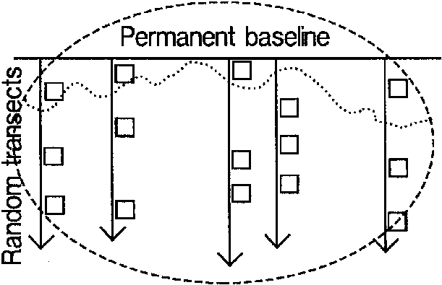
- Use permanent transects perpendicular from the shoreline or stream bank (Figure A.1) with quadrat plots to sample changes in herbaceous plant community, shoreline change, water level, and elevation over time.
Figure A1: Sketch of random transects and quadrats
- Initial placement of transects should be perpendicular to the baseline, randomly spaced, with quadrats placed randomly along the transects. Stratify measurements as necessary to capture variation in any parameters of interest.
- Use 1 m² plots.
- Permanent plots are preferred, as they facilitate capturing change over time, and, once established, they reduce sampling time. However, be careful when walking across the same areas over time as this can result in visible damage to the restoration. Be sure to avoid walking within the plot area itself.
Guidelines for different NBS types
- For projects at a marine, estuarine, or Great Lakes shoreline, transects should capture the water edge of vegetation, capture transition zones in elevation or vegetation, and should continue through the upper marsh or approximate Mean Higher High Water (MHHW). If practical, continue to any upland portion of the restoration site.
- For marsh restoration, consider using ~25-50 total plots, depending on the size of the project.
- For riparian restoration, transects should extend from the streambank to the edge of the restored area.
- For living shorelines,
  - If the living shoreline is attached to the shoreline,
    - Make short transects from a shore-parallel baseline, as above. It may be sufficient to have, for example, one upland quadrat, one marsh quadrat, one on the structure crest, and one on the seaward edge of the structure.
    - If the required metrics include oyster metrics, sample at the end of the transect, e.g. at the structure’s seaward edge. It is not necessary to map the entire shore-attached living shoreline as an oyster reef.
  - If the living shoreline includes a detached breakwater,
    - Create short transects as above to capture sedimentation and marsh growth behind the structure.
    - If it is safe to continue the transect onto the detached breakwater, capture elevations at the deepest area between the shore and structure (if possible), the structure’s landward edge, the crest, and the seaward edge.
    - If it is not safe (e.g., due to wave or current conditions) to continue the transect to the detached breakwater, include any notes on the structure’s condition in the general notes fields in the data reporting template.
    - If the required metrics include oyster metrics, treat the detached breakwater as an artifical oyster reef structure and proceed with the oyster metrics as described in the relevant appendix.

Shoreline Position
Intent: Measuring the change in shoreline position gives information on erosion and accretion, often key performance goals for shoreline NBSs designed to attenuate wave energy.

Marine or estuarine shoreline position method 1:
- Define the shoreline as the seaward edge of emergent vegetation.
- Record the shoreline location along each transect.
Marine or estuarine shoreline position method 2:
- If high-resolution elevation data is available, such as a digital elevation model based on Lidar or other remote sensing, the shoreline may be defined as the intersection of the land surface with the Mean High Water (MHW) elevation. MHW can be identified from water level loggers such as a NOAA tide station.
- Use Geographic Information System (GIS) software to define transects as specified above. Sample the elevation data and shoreline position to these transect locations for reporting.
Riverine or lacustrine shoreline position method:
- For a riverine or lacustrine site, the shoreline or bank location along a transect may be defined by the Ordinary High Water Mark (OHWM). The OHWM is approximately the location of the change in soil and vegetation type that marks land that is typically underwater versus land that is typically not underwater.
- Transects for quadrat sampling should extend into the water beyond the OHWM at least as far as the river-ward or lake-ward edge of emergent vegetation.
- Record the shoreline location along each transect.

Percent cover by species
Intent: Vegetation is nearly always a key provider of ecosystem services in coastal NBS. For example, by providing hydraulic roughness, the vegetation of a tidal marsh gives it the ability to attenuate wave energy. This method is intended for herbaceous vegetation such as marsh grasses. For tree planting, see Appendix H.
- Identify all plant species found in the quadrat. You may define a generic vegetation type for species making up a small portion of the site. For each species, estimate and record the total percent cover by category (1-9) according to the North Carolina Vegetation Survey (NCVS) vegetation categories outlined below (Peet et al. 1998). For marine/estuarine sites, use the same coverage categories to additionally identify and record the cover of live oyster, live mussels, and wrack.
Cover Range | NCVS category
Solitary/Few/Small | 1
0.1-1% | 2
1-2% | 3
2-5% | 4
5-10% | 5
10-25% | 6
25-50% | 7
50-75% | 8
75-95% | 9

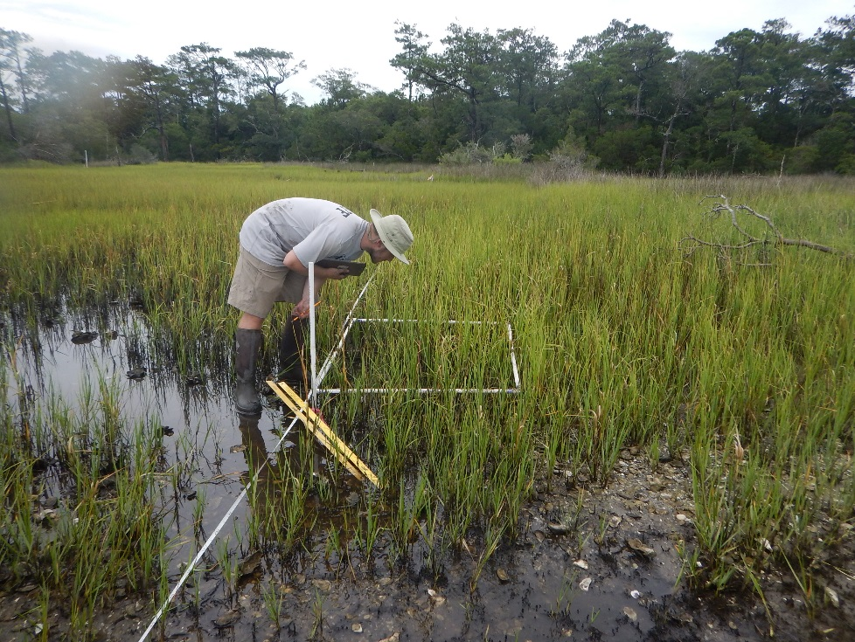
Figure A.2: Estimating percent cover at permanent sampling location along transect. Take care to walk on opposite side of transect tape to avoid inadvertently standing in plot when setting up transect tape.

Elevation
Intent: Elevation of the land surface is a key parameter of a wetland. For intertidal wetlands in particular, their elevation must increase with sea level to allow emergent vegetation to survive and continue providing ecosystem services including habitat and wave attenuation.

General guidelines on benchmarking for elevation and water level:
- This section describes one traditional method of establishing a benchmark to survey elevations. You may use another method, such as RTK-GPS, instead. You may use drone-based or other remote sensing methods as long as you (a) tie your measurements to a vertical datum and (b) sample your data along transects so it may be reported in the standard NCRF data reporting template.
- If you will use a physical benchmark, establish it in a fixed location using materials that can withstand the saltwater environment. A steel rod driven >5 feet into the ground and encased in concrete is acceptable (Figure A.2, A.3, A.4). Establish approximately one benchmark for every acre of project.
- If marsh accretion is of interest, optionally follow the protocol laid out in “SOP 3: Installing an RSET Mark” in Lynch, et al. (2015).

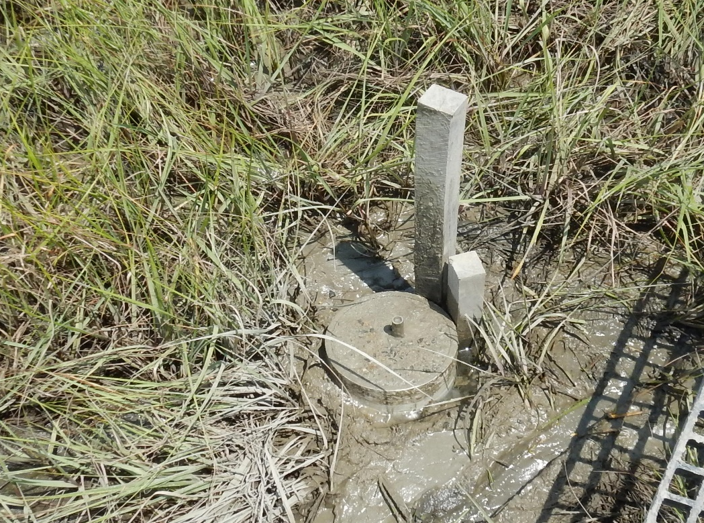
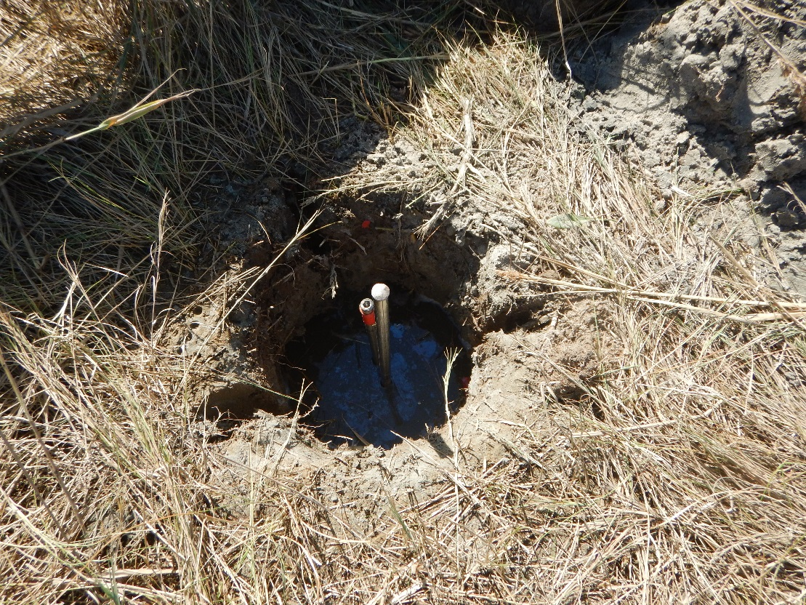
Figure A.3: Rod installed into ground before installation of cement-filled PVC collar.
Figure A.4: Rod with PVC “collar” filled with cement

Elevation method:
- These techniques provide consistent results, and the ability to measure change over time, when reliant on a permanent reference benchmark (Figure A.5). If none are available, one should be installed.
- Marsh surface elevation can be obtained with RTK GPS units.
- Laser or optical leveling techniques (Figure A.6) can also be used to determine difference in elevation (~cm of change) from a benchmark to each permanent plot.
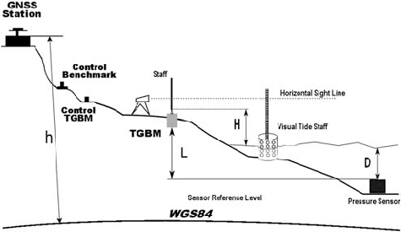
  - Place the leveling rod/rover pole in the center of the plot. If the ground is very soft, you may need to use a small item placed on the sediment surface to keep the leveling rod from sinking in the mud while you take your reading (the lid of a Tupperware container works well). If you do this, be sure to use it on all plots throughout the site.
Figure A.5: Sketch depicting monitoring site including various equipment and location of measurements within the site.

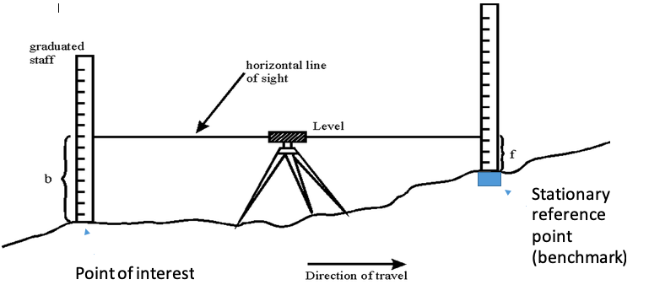
Figure A.6: Sketch of leveling technique

Water Level
Intent: This metric enables you and NFWF to determine the amount of time the restored wetland is underwater (the hydroperiod), a key explanatory variable for the viability and persistence of a wetland. Ideally, the post-restoration hydroperiod should be predicted as part of the planning process.

General guidelines for water level measurements:
- You may not need to collect these data yourself: existing monitoring stations from a government, nonprofit, or academic institution may already be operating near your site, with data freely available online. Consider influences that may cause measurements at the station to differ from your site when deciding whether the station data is representative of conditions at your site.
- Projects with large or complex geographies, where one logger may not provide representative data for every site, may need more than one logger.
- Data should be collected at 15-minute intervals for durations of at least 30 days. Because logging should include pre-construction, immediate post-construction, and one-year-post-construction monitoring periods, continuous sampling over this entire duration is also a good option.
- A benefit of long-term logging is that it may capture floods, helping to explain any impacts on the performance of the NBS.
Note on optional wave measurements for tidally influenced sites:
Many available water-level loggers also measure waves, and the logger’s software can calculate wave climate parameters such as the significant wave height and the wave energy. While wave measurements are not required by the NCRF, understanding the wave climate at a site is key to understanding the performance of coastal NBSs that are designed to attenuate waves. For these NBSs, the difference in wave height or energy in front of and behind the project indicates the amount of attenuation.

Two nearby loggers may be required to monitor hydrologic restoration:
- For some projects, two nearby loggers should be used:
  - For projects in which side channels or off-channel habitat (e.g., floodplain) is created, use one logger in the restored side-channel or off-channel area and one in the adjacent stream, estuary, etc.
  - For projects in which flow restrictions are removed (e.g., in floodplain reconnection), created (e.g., to manage salinity), or otherwise modified, use one logger on each side of the flow restriction.
- The purpose of having two loggers is to correlate the inundation period in the area of restricted (or formerly restricted) flow with adjacent water levels outside the restriction.
Water level method 1 (tidal or riverine):
- Use one or more existing monitoring stations from a government, nonprofit, or academic institution. Consider NOAA tide gauges (https://tidesandcurrents.noaa.gov/) and USGS (https://waterdata.usgs.gov/nwis/rt) or USACE (https://rivergages.mvr.usace.army.mil/) river gages, as appropriate.
- Consider any influences that may cause measurements at the monitoring station to differ from your site, such as distance and tidal or other flow restrictions, and determine whether the monitoring station data is a good substitute for measurements taken directly at your site. If not, install a logger at your site as described below.
- Make sure to keep date and time associated with each measurement.
Water level method 2 (riverine):
For riverine NBSs, use a staff gauge surveyed into the same elevation benchmark (see above) as the elevation measurements.

Water level method 3 (tidal):
- Install a pressure sensor-style water level logger on site. Be sure to select a model that is resistant to saltwater, if appropriate.
- The sensor should be attached to a stable fixed structure (piling or pier) if one is available. If not, attach the sensor to a PVC or rebar pole driven into the substrate far enough to ensure stability (several feet depending on the level of consolidation in the substrate).
- Sensors can be installed inside of a vented PVC pipe for added protection. The sensor should be attached firmly so that there is no movement in position of the reading lens over time.
- Ideally, to capture the full range of the tide, the sensor should be installed below MLW if possible.
- An additional barometric sensor should be installed nearby so that water levels may be corrected for changes in atmospheric pressure (per manufacturer instructions).
- Determine the elevation of the installed sensor relative to the benchmark so that water levels may be interpreted with respect to marsh surface elevation.
- If multiple loggers are being installed, make sure they are surveyed into the same benchmark and datum.
- Record date and time for each measurement.
- Make sure any equipment you use to collect your own data is properly calibrated.

Salinity
Intent: Salinity is a key environmental parameter in estuaries. Coastal NBSs that use water control structures to limit salinity should monitor it to understand the effectiveness of the structure and the condition of the ecosystem.
Measurement techniques:
There are several technologies for measuring salinity, including conductivity probes, refractometers, hydrometers, and chlorinity methods. All these are affected by temperature, which should be measured at the same time for an accurate salinity calculation.
Salinity method 1, continuous measurement:
- As with water level measurements, continuous salinity measurements may be available from an existing government, nonprofit, or academic source, such as a NOAA tide station.
- Consider influences that may cause measurements at the station to differ from your site when deciding whether the station data is representative of conditions at your site.
- If no appropriate measuring stations are available, install an instrument with a data logger at your site. Continuous data loggers for commonly measured environmental parameters, such as conductivity, temperature, and depth (CTD), are available at low cost.
- A benefit of long-term logging is that it may capture floods better than field surveys can, helping to explain any impacts on the performance of the NBS.
Salinity method 2, single measurements during field survey:

- Measure with a conductivity probe, CTD, or other portable instrument.
- Measure salinity whenever other field monitoring is conducted and, if possible, at frequent intervals in between.
- If it is possible and safe to do so, take measurements immediately after storms to capture changes in conditions related to the storm.

Citations and Further Reading

Surface Elevation Tables (SETs):

For information on information on installing a SET and standard operating procedures, see Lynch, et al. (2015); see “SOP 3: Installing an RSET Mark” for information on installing a steel rod with a receiver for attachment of a SET arm:

Lynch J.C., Hensel, P., and Cahoon, D.R. 2015. The surface elevation table and marker horizon technique: A protocol for monitoring wetland elevation dynamics. Natural Resource Report. NPS/NCBN/NRR—2015/1078. National Park Service. Fort Collins, Colorado https://irma.nps.gov/DataStore/Reference/Profile/2225005.

Vegetation and North Carolina Vegetation Survey (NCVS):

Peet, R.K, Wentworth, T.R., & White, P.S. (1998). A Flexible, Multipurpose Method for Recording Vegetation Composition and Structure. CASTANEA, 63(3), 262-274. https://www.nfwf.org/sites/default/files/coastalresilience/Documents/ncvs-protocol.pdf

Tide gauge data:

For NOAA tide gauge data, see https://tidesandcurrents.noaa.gov/
For USGS river gage data, see https://waterdata.usgs.gov/nwis/rt
For USACE river gage data, see https://rivergages.mvr.usace.army.mil

Salinity:
“Electrical Conductivity/Salinity Fact Sheet.” California State Water Resources Control Board. https://www.waterboards.ca.gov/water_issues/programs/swamp/docs/cwt/guidance/3130en.pdf. Accessed November 2025.

Ohrel, R. L., and K. M. Register. "Voluntary estuary monitoring manual." Environmental Protection Agency: Washington, DC, USA (2006): 2015-09. https://www.epa.gov/sites/default/files/2015-09/documents/2009_03_13_estuaries_monitor_chap14.pdf

Other references:

Baggett et al., 2014. Oyster Habitat Restoration Monitoring and Assessment Handbook. The Nature Conservancy, Arlington, VA, USA. https://chnep.wateratlas.usf.edu/upload/documents/Oyster-Habitat-Restoration-Monitoring-And-Assessment-Handbook.pdf

National Oceanographic and Atmospheric Administration (NOAA). (December 2024 Update). NOAA Restoration Center Implementation Monitoring Guide: Guidance for Proposing and Conducting Tier 1 Monitoring. https://www.fisheries.noaa.gov/s3//2025-01/Copy-of-Final_Grantee-Guidance-for-Tier-1-Monitoring_6DEC24Update.pdf

Harman, W., R. Starr, M. Carter, K. Tweedy, M. Clemmons, K. Suggs, C. Miller. 2012. US Environmental Protection Agency, Office of Wetlands, Oceans, and Watersheds, Washington, DC EPA 843-K-12-006.
A Function-Based Framework for Stream Assessments and Restoration Projects
https://www.mvp.usace.army.mil/Portals/57/docs/regulatory/Mitigation/A%20Function-Based%20Framework%20-%202012%20EPA%20FWS.pdf

Natural Resources Conservation Service. (2009). Stream Visual Assessment Protocol Version 2 (National Biology Handbook, Subpart B, Part 614). U.S. Department of Agriculture. https://www.nrcs.usda.gov/sites/default/files/2022-10/Stream-Visual-Assessment-Protocol-Version-2.pdf

USACE Unified Stream Methodology
https://www.nao.usace.army.mil/Portals/31/docs/regulatory/commonreq/USM_Final_Draft.pdf

