Appendix B: Beach and Dune Restoration Monitoring Metrics
Monitoring overview: These metrics indicate the size and persistence of the beach and dune system. Width, height, and volume are measures of the system’s ability to provide habitat, hazard mitigation, and other ecosystem services.

For volume and linear measurements, report the values per-transect and summary values: total volumes, average widths, etc.

General guidelines on measuring beach and dune topography:
- To survey elevations for the beach/dune metrics in this appendix, you may use a method such as RTK-GPS, traditional survey equipment and methods, or remote-sensing methods such as drone-based photogrammetry, lidar, etc.
- These beach and dune parameters can be derived from ground-based elevation profile surveys or from remotely sensed data.
- Whichever method you use, report the vertical datum.

Beach and Dune Elevation Profile
Intent: A cross-shore elevation profile can indicate whether a shoreline is eroding or accreting, changes to key features, and sand volume changes at the restoration site. It can be used to derive the width, height, and volume measurements below.

Method 1: Remotely sensed data
- If you use remote sensing (e.g., photogrammetry from a UAS), use the resulting elevation surface to calculate these parameters in the remote sensing software package or another GIS.
- You may wish to derive elevation profiles by sampling the surface along transects like those described here for traditional survey methods; in that case, your width, height, and volume calculations will be the same as for measured profiles.

Method 2: Ground-based survey:

- Thes profiles will be used to calculate all other beach and dune metrics in this appendix except grain size.
- Establish a survey baseline approximately parallel to the shoreline, at least as far landward as the landward dune toe.
- Establish elevation survey transects perpendicular to the baseline, from the baseline to the mean low water mark (MLW), or to closure depth, depending on project goals. The shoreface is the area from the shoreline seaward to the depth of closure.
- Place transects every 400-800 feet. More transects may be advisable depending on project goals.
- Mark the transect ends with GPS. It may be advisable to put a durable marker, such as rebar, to mark the start of each transect.
- Include transects where there are changes in topography.
- If possible, establish transects in control areas beyond the project site. Control profiles should go beyond the project area, approximately 1,000 feet beyond any major structures or up to 1/2 mile for long beaches without major topographic variation.
- Start survey on landward side of project and move seaward, taking elevation measurements at regular intervals, including at all changes in slope; key features (dune toe, swales, berms, berm ponds, ridges, runnels, wrack and high water lines, etc.), including those requested here; and any significant changes in elevation along the transect.
- Surveys should move into the water’s edge at low tide to maximize the extent of coverage area.
- Take enough measurements of elevation and distance along the profile to include all changes in slope. Measurement spacing should usually be less than 20 feet. Optimal sampling balances good spatial resolution with time and financial constraints.
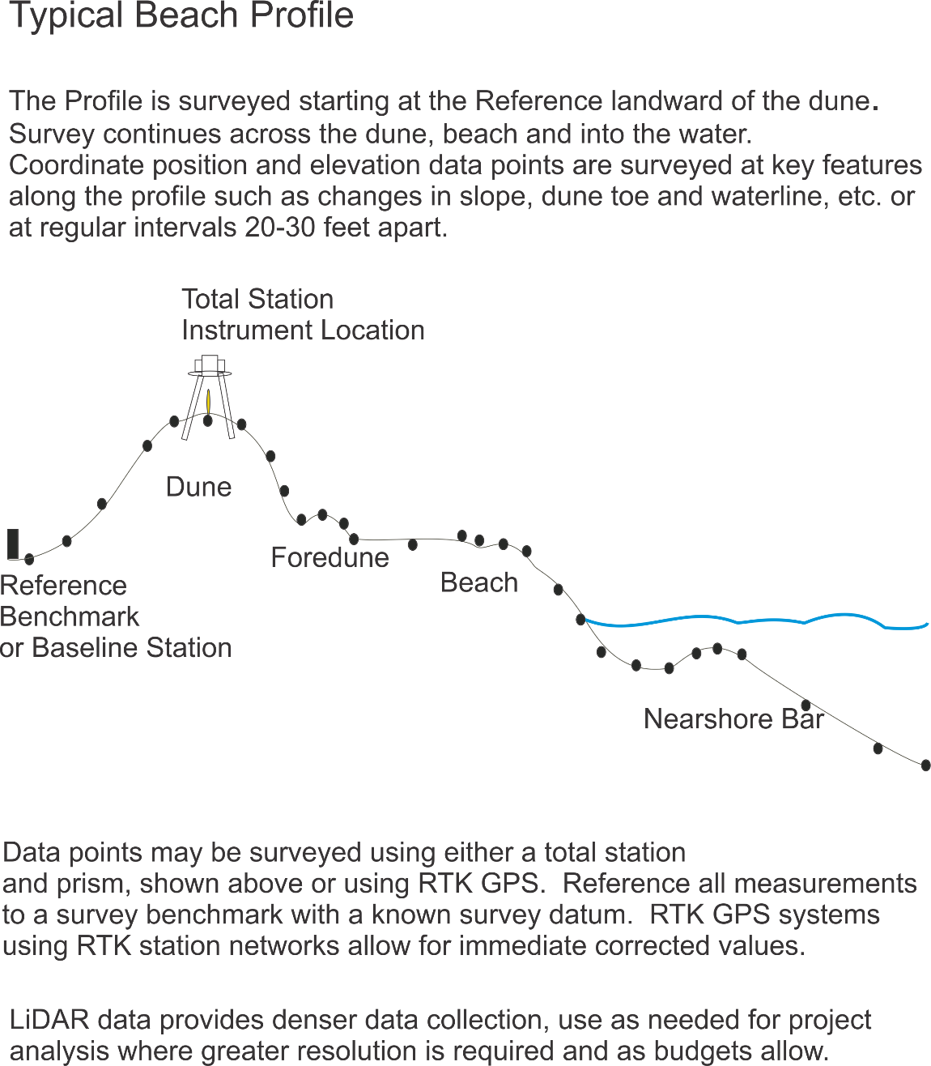
Sketch of Beach Profile Methods
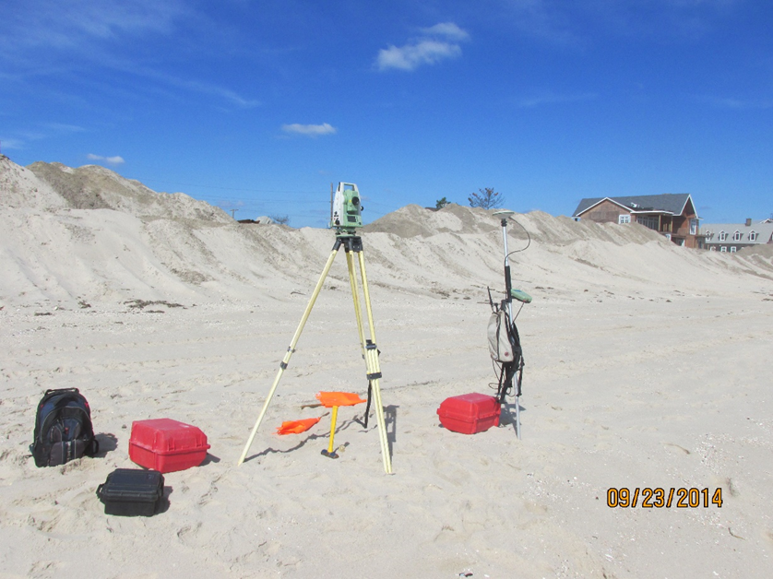
Figure 8: Image of traditional survey equipment used for Beach Profiles (Total Station and RTK GPS Rover)
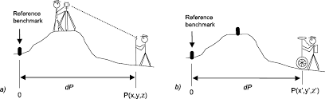
Figure 9: Character sketch of beach profiling using a) Total Station and b) RTK GPS

Shoreline Position
- The shoreline will be defined to be the intersection of the beach profile with the mean high water (MHW) elevation.
- Calculate the horizontal distance along the transect to the shoreline.

Beach Width
- The beach width is the horizontal distance from the landward dune toe to the shoreline.

Beach-Dune Volume
- The (subaerial) beach volume is the volume of a prism formed by the beach profile area and the alongshore distance from one parallel transect to the next.
- Calculate the area under the beach profile, that is, the area of the polygon formed by the beach profile at the top, MHW elevation at the bottom, and a vertical line at the back of the transect.
- Multiply this area by the alongshore distance to the next transect to find the beach volume.

Backshore Width
- The backshore is dry except in extreme conditions. It extends from the limit of high water swash (usually marked by a small berm) to the dune toe.
- Measure backshore width horizontally along the transect from the berm to the seaward dune foot.

Dune Width
- Dune width is the horizontal distance along the transect from the (landward) dune toe to the seaward dune toe (the dune heel).

Dune Height
- Dune height is the crest height along the profile.

Dune Volume
- Dune volume can be calculated like beach volume but with only the portion of the profile that includes the dune (i.e., from dune toe to dune heel).

Grain Size

Method 1: Sediment core samples
- This is the recommended method. Take 20cm thick sediment core samples. Sample from dune base to lower beachface slope to determine textural variability across the beach system. Samples may be processed by sieving, commercially, etc.
- Report d50, the median grain diameter.

Method 2: Handheld sand gauge
- This is a more low-tech method that can be conducted in the field. Sand gauges are small, credit-card sized, plastic charts with calibrated samples of sieved sand mounted on the face. Using a hand lens and sand gauge chart, compare beach samples to calibrated samples for an estimate of the grain size.
- Report the typical grain size from the gauge.

Citations and Further Reading
Burgess, H., Herring, C., Lippiatt, S., Lowe, S. and Uhrin, A.V., 2021. NOAA Marine debris monitoring and assessment project shoreline survey guide. https://marinedebris.noaa.gov/protocol/noaa-marine-debris-monitoring-and-assessment-project-shoreline-survey-guide

The Coastal Wiki https://www.coastalwiki.org/ is an informal but useful source for definitions and explanations of coastal geomorphologic concepts.

