Appendix D: Coral Reef Monitoring Metrics

Monitoring Overview: This appendix contains monitoring metrics relevant to coral reef restoration projects, with a focus on projects that outplant corals. These metrics are indicators of the reef’s ecological status and ability to provide habitat and wave attenuation benefits. This appendix is largely adapted from, and contains excerpts from, The coral reef restoration monitoring guide: Methods to evaluate restoration success from local to ecosystem scales (Goergen et al., 2020).

Guidelines for Determining Survey Sites:
It is strongly recommended that monitoring include a reference site and a control site for comparison in addition to the restoration site. The metrics assessed and the timing/frequency of assessment will vary at the three different sites. The timing and frequency requirements for the different metrics are provided per site type in the Metrics and Protocols table below. Be sure to determine the GPS coordinates for each site surveyed and use fixed transects as appropriate.
- Restoration site: Defined as the project area in which the coral restoration will take place.
- Control site: Determine a nearby site of similar condition that will not receive outplants.
- Reference site: Select a nearby site that is considered ‘healthy’ or ‘near natural’ for this area/region used to establish the ecological targets of the restoration project. Reference sites should mirror the restoration site in appropriate species, structure, and abiotic processes to the greatest extent possible. Guidance to evaluate a good representative reference site can be found in Appendix 2 of the Coral reef restoration monitoring guide.
- In some cases, the control and reference may need to be the same site, or a reference site may not be available. In this case, look for historical data to use instead.

Coral Reef Area
- Measure pre-restoration, within one month of outplanting, and one year post-outplanting, ideally continuing annually.
- For the restored area, determine the sum of the areas of the initial restored plots (where coral outplants are spaced <2 meters apart).
- One year post-restoration, update this footprint based on either spread or mortality of outplanted coral, including dispersed fragments (see figure below). For more detail, see Goergen et al. (2020), p. 25.

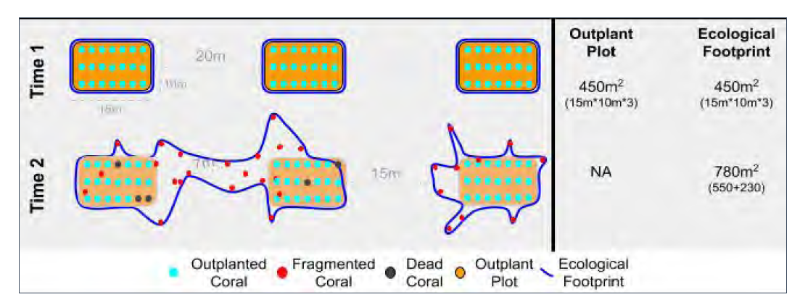
Example of the change in number of Ecological Footprints as restoration corals fragment and spread across the site filling in the gap between outplant corals. After Goergen et al. (2020), Figure 14.

Coral Species Abundance and Survival
- Pre-restoration, count the number of colonies/outplants within the restoration site footprint and sample the mean coral width (in cm) for each species at all three sites. Within one month post-outplanting, conduct the same survey at the restoration site only. Annually post-restoration, conduct the same survey at both the restoration site and the reference site (add control site if time/funding permits).
- Present the percentage of corals per size class/species based on methods in the Coral reef restoration monitoring guide. Estimate the mortality by percent live tissue cover either as some subset of mortality per outplant or the percentage of outplants showing signs of mortality (dead tissue) (see Figure 16 below). For more detail, see Goergen et al. (2020), p.36.
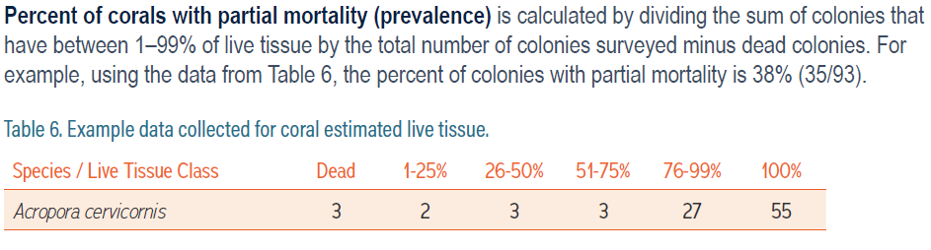
Example data collected for coral estimated live tissue. After Goergen et al. (2020), Table 6.

Coral Reef Rugosity and Height
- Within one month post outplanting, sample the number of colonies/outplants within the restoration footprint and the mean coral height (above the fragment’s substrate) for each species at the restoration site. Annually post restoration, conduct the same survey at the restoration site (see Figure 17 below).
- For some reef types, a reef height assessment via transect profile (also known as chain length) may be appropriate to evaluate change in structure and height of the restored site over time.
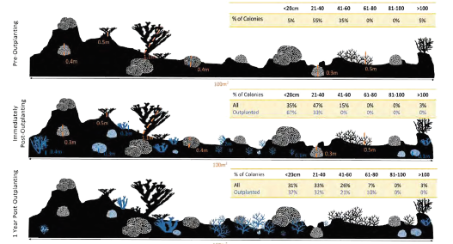
Figure 17: Estimated height of coral colonies pre-outplanting, immediately post-outplanting, and 1-year post-outplanting using height bins. After Goergen et al., Figure 35.

Fish Species Abundance
- Establish reference and control sites for comparison to the restored site.
- Pre-restoration, sample the biomass of key species, families, and guilds at the reference site, control site, and restoration site.
- Within one-month post-outplanting, sample (at least) the restoration site.
- One year post-restoration, sample at the restoration site and the reference site.
- Continue annual sampling at the three sites, if possible.

Citations and Further Reading
Goergen, E.A., S. Schopmeyer, A.L. Moulding, A. Moura, P. Kramer, and T.S. Viehman. 2020. Coral reef restoration monitoring guide: Methods to evaluate restoration success from local to ecosystem scales. NOAA Technical Memorandum NOS NCCOS 279. Silver Spring, MD. 145 pp. doi: 10.25923/xndz-h538. https://repository.library.noaa.gov/view/noaa/27135

