Appendix E: Seagrass Monitoring Restoration Monitoring Metrics
Monitoring Overview: To help evaluate seagrass restoration projects, this document outlines methods to use permanent transects perpendicular from the shoreline with quadrat plots to sample changes in the plant community over time. These methods are largely after Victor and Oldiais (2007). Seagrass-Watch, cited below, also provides comprehensive guides for various bioregions.
Monitoring at reference and control sites is recommended, but only monitoring at the restored site is required.
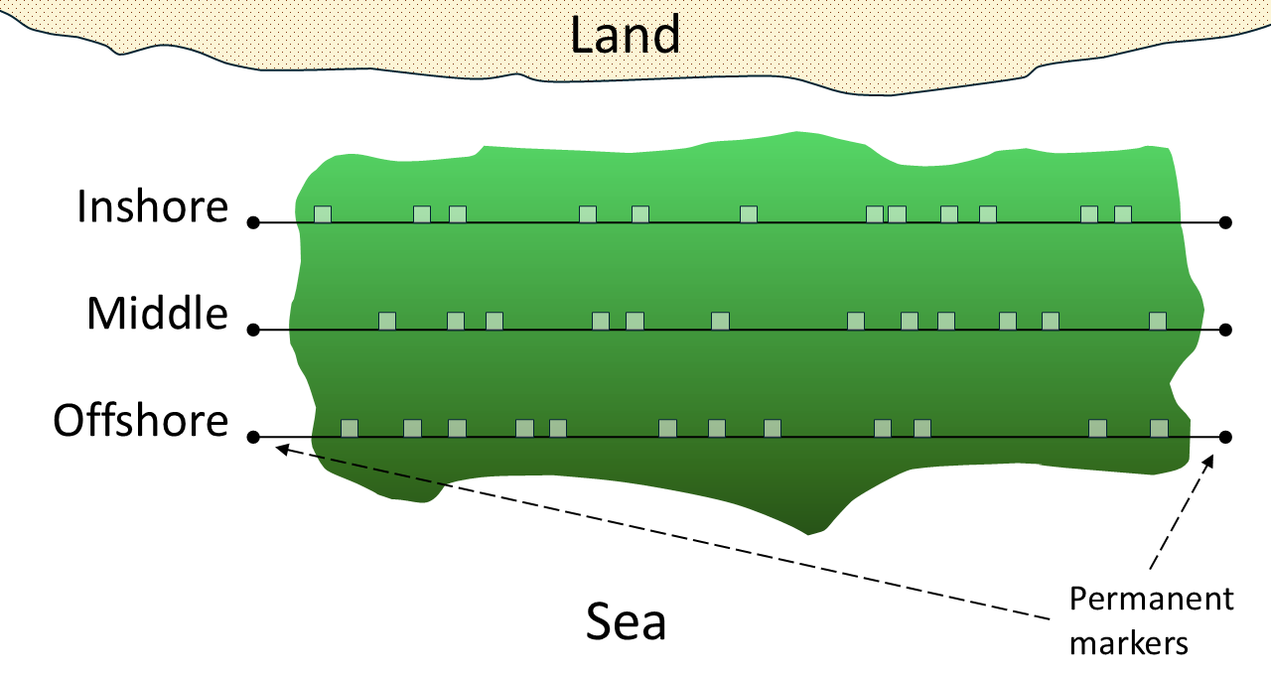
General guidelines for transects and quadrats:
Sketch of parallel transects and quadrats, after Victor and Oldiais (2007) and Short, et al (2015).
- Orient the transects parallel to each other, roughly parallel to depth contours, marking ends with GPS.
- Optionally, measure and record the bottom elevation
- Use at least three transects.
- If possible, install permanent markers at the ends of each transect. Use rebar or a pole with flagging or a float to ensure visibility. Make sure to comply with your permit and any applicable rules and regulations for your area if installing permanent markers.
- A quadrat is a square frame. Dimensions of 0.5 m x 0.5 m (0.25m²) are suggested.
- Place quadrats randomly along each transect.
- Use ~25-50 plots per site, depending on the size of the project. The example pictured shows 12 quadrats for each 50 m transect. Or, optionally, to estimate the minimum number of quadrat samples needed for statistical analysis, use the procedure given in Baggett, et al. (2014), p. 11 and described in Appendix D for live oyster density measurements.

Percent cover of seagrass
Intent: The percentage of substrate covered by seagrass is a key indicator of the meadow’s ability to persist and provide ecosystem services. The meadow’s species composition is a key indicator of its ecological status.
General guidelines for seagrass percent cover measurements:
- Place the quadrat on the preselected location along the transect. Stand on the offshore side.
- Determine all seagrass species present in the quadrat.
- Record estimated percent cover of each seagrass species within the quadrat. Refer to https://www.seagrasswatch.org/manuals/#standards for graphical guides for estimating seagrass percent cover by genus.
- Total percent cover of seagrass is the sum of the percent cover of each seagrass species.

Seagrass canopy height
Intent: The canopy height of a seagrass meadow and the change in this value through time are key indicators of the meadow’s ability to persist and provide ecosystem services.
- For the dominant seagrass species, randomly select a clump of seagrass blades from the quadrant. Extend the leaves to their maximum length (without uprooting the clump).
- Measure the length of the leaf blades from the sediment to the leaf tips (in cm) with a ruler.
- Ignore the tallest 20% of blades and visually estimate the average length of the remaining blades. Record this number.

Citations and Further Reading
“Global Seagrass Research | Methods & Manuals | Seagrass-Watch.” Seagrass-Watch. https://www.seagrasswatch.org/manuals/. Accessed November 2025.
Neckles et al. 2012. Integrating Scales of Seagrass Monitoring to Meet Conservation Needs. Estuaries and Coasts 35(1), 23-46. https://you.stonybrook.edu/theawesomepeterson/files/2012/10/neckles-et-al-2012.pdf
Short, et al. 2015. SeagrassNet Manual for Scientific Monitoring of Seagrass Habitat, Worldwide Edition (2015 rev.). University of New Hampshire. https://www.seagrassnet.org/seagrass_manual_2015.pdf
Victor and Oldiais. 2007. Manual for monitoring seagrass in Palau. National Oceanic and Atmospheric Administration, Palau International Coral Reef Center. https://repository.library.noaa.gov/view/noaa/596

