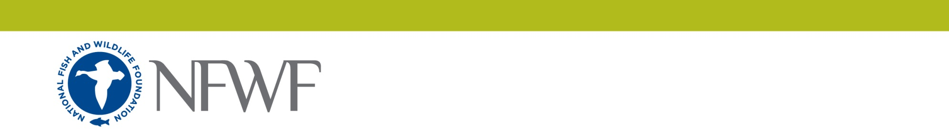
Instructions: Save this document locally and complete the narrative in the format provided. Do not change the format (Calibri 11pt font, ¾ inch margin). The final narrative should not exceed six (6) pages. Do not delete the text provided below. Upload completed document as a PDF or MS Word file into the online application as instructed.
Five Star Program
Full Proposal Project Narrative

I. Project Context
1. Specify the total acres the project will restore/impact and explain the need for the project.

2. Specify the ecological impacts of the project and how it will contribute to watershed health.

3. Specify who will be involved in the planning and implementation phases of the project, including each partner and number of community members directly engaged or impacted.

4. If the project is located in one of areas prioritizing tree canopy enhancement (Miami, FL; Memphis, TN; Oakland, CA; or Pittsburgh, PA), propose and describe the type of day-long community service event for up to 50 employees of our corporate sponsor and the partnership’s capacity to carry out this event. Answer only if applicable.

II. Conservation and Outreach Activities
5. For each on-the-ground activity included in the metrics section, identify and describe each activity that the partnership will undertake and how each activity will meaningfully advance the project’s conservation outcomes. If the project is focusing on agriculture, please also include goals for expected pounds of food produced and donated.
6. For each outreach and capacity activity identified in the metrics section, describe each activity that the partnership will undertake and explain how each activity will meaningfully advance capacity outcomes.
7. What are the long-term community and conservation outcomes for this project and activities for measuring progress?

III. Collaboration & Sustainability
8. Complete the table to describe how all partners are involved in the project. The project must have at least five partners contributing a variety of expertise to the project. Add rows as needed.
 | Partner (organization or individual) | Qualifications  (project-related expertise) | Contribution(s)  (goods or service provided)
Example: | Girl Scout Troop #242 | Manual labor | Volunteer hours to construct trail bridge and signage on nature trail
1
2
3
4
5
Total:
9. Describe how the project partnership will build capacity to expand community stewardship locally. Discuss the connections the partnership has with the target audiences and how this will influence future efforts.
10. Explain the plan for monitoring project achievements beyond the project period, including how the partnership will ensure the sustainability of project results.

